
REPUBLIC OF GHANA

COMPOSITE BUDGET

FOR 2022-2025

PROGRAMME BASED BUDGET ESTIMATES

FOR 2022

NORTH DAYI DISTRICT ASSEMBLY

Resolution by the Assembly
AT AN ORDINARY MEETING OF THE NORTH DAYI DISTRICT ASSEMBLY HELD ON WEDNESDAY, 29TH OCTOBER 2021, THE 2022 COMPOSITE PROGRAMMED BASED BUDGET WAS APPROVED.

Compensation of Employees Goods and Service Capital Expenditure
GH¢1,646,487 GH¢2,486,965 GH¢4,423,054

Total Budget GH¢8,556,506

GILBERT AKABA. HON. EDWARD BRIKU BOADU. CAPT.(RTD)
[DISTRICT COORDINATING DIRECTOR] [PRESIDING MEMBER]

Table of Contents
PART A: STRATEGIC OVERVIEW OF THE ASSEMBLY 4
Establishment of the District 4
Population Structure 4
Vision 4
Mission 5
Goals 5
Core Functions 5
District Economy 6
Key Issues/Challenges 12
Key Achievements in 2021 12
Revenue and Expenditure Performance 16
Adopted National Medium Term Development Policy Framework (NMTDPF) Policy Objectives 20
Policy Outcome Indicators and Targets 20
Revenue Mobilization Strategies 21
PART B: BUDGET PROGRAMME/SUB-PROGRAMME SUMMARY 22
PROGRAMME 1: MANAGEMENT AND ADMINISTRATION 22
PROGRAMME 2: SOCIAL SERVICES DELIVERY 35
PROGRAMME 3: INFRASTRUCTURE DELIVERY AND MANAGEMENT 49
PROGRAMME 4: ECONOMIC DEVELOPMENT 56
PROGRAMME 5: ENVIRONMENTAL MANAGEMENT 62
PART C: FINANCIAL INFORMATION 67

PART A: STRATEGIC OVERVIEW OF THE ASSEMBLY

Establishment of the District
The North Dayi North Dayi District is one of the eighteen (18) administrative districts in the Volta region of Ghana, District capital Anfoega. It was curved out of Kpando Municipal Assembly in 2012, established by Legislative Instrument (LI) 2076 of 2012 and inaugurated Thursday, 28th June 2012. The Assembly comprises of Twenty-Three (23) electoral areas, six (6) Area Councils and twenty-three (23) Unit Committees. The Sub-District structures of the Assembly are;
Anfoega Area Council
Vakpo Area Council
Wusuta Area Council
Tsrukpe/Botoku/Tsorxor Area Council
Awate Area Council
Aveme/Tsyome Sabadu Area Council.

Location and Size;
The North Dayi District Assembly office is situated at Anfoega in the Volta region of Ghana. It is about 70km from Ho and 250km from Accra. The District lies within Latitude 60 20’N and 70 05’N and Longitude 0º 17’E. It shares boundaries with Kpando Municipal to North, South Dayi District to the South and Afadzato South District to the East. The Volta Lake stretches over 80km of the costal line, demarcates to Western boundary. The District covers a total land area of 462.8square km representing 2.2 percent of the total land in the Volta region. The district has nearly 30 percent of land being submerged by the Volta Lake.

Population Structure
The population of North Dayi is 39,913 (2010 Population and Housing Census) and this is expected to reach 53,053 by 2022, at 2.4 percent growth rate. The population of the district also represents 1.4 percent of the total regional population. The male population projected at 25,996 constituting 49 percent whilst female projected 27,057 forming the remaining 51 percent. The District is peri-urban.

Vision
To be one of the leading performing District Assemblies in the practice of good governance in Ghana.

Mission
To facilitate the improvement in the quality of life of the people within the Assembly’s jurisdiction through equitable provision of services for the total development of the District within the context of good governance

Goals
To improve upon the general living conditions of the citizenry through concerted efforts of all stakeholders to achieve self-reliance, self-sufficiency, peace, accountability, unity of purpose with the creation of enabling environment for the growth of the private sector led economy inclusiveness based on the principle of good governance

Core Functions
The North Dayi District Assembly derives its core functions from the Local Governance Act, 2016, Act 936 and is outlined below:
- Exercise political and administrative authority in the district, provide guidance, give direction to, and supervise the administrative authorities in the district.
- Performs deliberative, legislative and executive functions.
- Responsible for the overall development of the district and shall ensure the preparation of development plans and annual and medium-term budgets of the district related to its development plans.
- Formulate and execute plans, Programmes and strategies for the effective mobilization of the resources necessary for the overall development of the district.
- Promote and support productive activity and social development in the district and remove any obstacles to initiative and development.
- Initiate Programmes for the development of basic infrastructure and provide municipal works and services in the district.
- Responsible for the development, improvement and management of human settlements and the environment in the district.
- Responsible, in cooperation with the appropriate national and local security agencies, for the maintenance of security and public safety in the district.
- Ensure ready access to Courts in the district for the promotion of justice.
- Initiate, sponsor or carry out studies that are necessary for the performance of a function conferred by Act 936 or by any other enactment.
- Perform any other functions provided for under any other legislation.
- Take the steps and measures that are necessary and expedient to
- execute approved development plans and budgets for the district;
- guide, encourage and support sub-district local government bodies, public agencies and local communities to discharge their roles in the execution of approved development plans;
- initiate and encourage joint participation with any other persons or bodies to execute approved development plans;
- promote or encourage other persons or bodies to undertake projects under approved development plans; and
- Monitor the execution of projects under approved development plans and assess and evaluate their impact on the people’s development, the district and national economy.
- Coordinate, integrate and harmonize the execution of Programmes and projects under approved development plans for the district, and any other development Programmes promoted or carried out by Ministries, departments, public corporations and any other statutory bodies and non-governmental organizations in the district.
- Finally, North Dayi District Assembly in the performance of its functions, is subject to the general guidance and direction of the President on matters of national policy, and shall act in co-operation with the appropriate public corporation, statutory body or non-governmental organizations

District Economy

- Agriculture
The District economy is mainly dependent on agriculture, mainly subsistent farming. The climatic condition of the District favorably supports the cultivation of variety of crops and livestock production. Agriculture in the District is still depends on unpredictable rainfall pattern.

CASH CROP
The main cash crops grown in the District are Mango, Cashew, Cocoa and few rice fields on small scales which are mostly grown in Vakpo-Fu, Konda, Wusuta and other communities.

- NON-TRADITIONAL CROPS
There are some non-traditional export crops that have emerged recently and mostly owned by local farmers. The main crops being cultivated are mango, pawpaw, pineapple, ginger, cashew and vegetables such as garden egg.

LIVESTOCK
The livestock sub- sector in the District is less developed. Common livestock found in the district include sheep, goats, cattle, pigs, ducks and local fowls but in less commercial quantities.
FISHING
Fishing is the dominant occupation for the people in the communities in the district living along the Volta Lake. Fishing is therefore, carried out along the entire southern border 80km along the Volta Lake. The major fishing communities include Awate Tornu, Tsorxor, Aveme Danyigba, Wusuta Kpebe and Botoku. Some fishing also takes place on the River Dayi. The fishes caught are mostly sold in the local markets in both fresh and smoked forms and also transported to urban markets such as Accra, Tema etc. for better prices.

- Road Network
The total road network within the District is 117km. This is made up of 15km Trunk Road, 44km bitumen surfaced Feeder Road and 58km un-surfaced Feeder Road which are in a deplorable state.

- Energy
The total electricity coverage within the District is estimated at 98%, this means that majority of the communities have been connected to the national grid through a lot of interventions such as the rural electrification project. The Assembly has also distributed solar lights to communities like Botoku Brada – Tornu to improve their lightening conditions as plans are far advanced to get them connected to the national grid. There are other sources of energy such as Liquefied Petroleum Gas (LPG), wood fuel among others in the District

- Health
The general health conditions in the district can be said to be improving over the years. The access to health care remains relatively good except for the Volta basin island communities. The district has fifteen (15) health facilities made up of one (1) mission hospital at Anfoega, seven (7) health centres (Aveme Danyigba, Wusuta, Awate, Tsyome Sabadu, Botoku, Tsrukpe, Vakpo) and seven (7) CHPS Zones (Anfoega Bume, Tokorme, Wadamaxe, Beme, Jordan-Nu, Kpebe, Tsorxor).

Health Facilities and Personnel
Name of Facility | Location | No. at Post | No. Required
Vakpo Health Centre | Vakpo | 18 | 36
Tsrukpe Health Centre | Tsrukpe | 4 | 6
Botoku Health Centre | Botoku | 3 | 7
Wusuta Health Centre | Wusuta | 5 | 8
Aveme Danyigba HC | Aveme | 4 | 6
Sabadu Health Centre | Sabadu | 3 | 6
Awate Health Centre | Awate | 4 | 6
Aveme CHPS | Beme | 3 | 6
Jordanu CHPS | Jordanu | 4 | 6
Wadamexe CHPS | Wadamexe | 4 | 6
Akukome CHPS | Anfoega | 2 | 6
Tokorme CHPS | Tokorme | 4 | 6
Kpebe CHPS | Kpebe | 3 | 6
Bume CHPS | Bume | 2 | 6
Anfoesec CHPS | Anfoega | 3 | 6
Tsorxor CHPS | Tsorxor | 3 | 6
Vakpo Fodome CHPS | Vakpo | 1 | 5
Vakpo Dunyo CHPS | Vakpo | 2 | 5
Vakpo Gborxome CHPS | Vakpo | 2 | 5
Vakpo Todzi CHPS | Vakpo | 2 | 5
Gadze CHPS | Wusuta | 2 | 5
Tsorkpeta CHPS | Wusuta | 3 | 5
Kpodzi CHPS | Botoku | 1 | 5
Awate Todzi CHPS | Awate | 1 | 5
Awate Agame CHPS | Awate | 2 | 5
Sabadu CHPS | Sabadu | 1 | 5
Resettlement CHPS | Aveme | 1 | 5
Danyigba CHPS | Aveme | 1 | 5
Source: District Health Directorate – North Dayi, 2020.

- Education

The District has various educational institutions which cater for different categories of the school going population. These include institutions from Pre-school, Basic school, Senior High school and Vocational School. Below is the summary.
Educational Institutions
SN | Item Description | Public | Private | Total
1 | Pre – School | 37 | 5 | 42
2 | Primary | 37 | 5 | 42
3 | Junior High School | 25 | 5 | 30
4 | Senior High/Technical | 3 | - | 3
5 | Vocational | 1 | - | 1
 | Total | 103 | 15 | 118

Source: GES – North Dayi, 2020

Distribution of Schools
Circuit | Pre – School |  | Primary |  | JHS |  | SHS/TECH
 | Public | Private | Public | Private | Public | Private | Public | Private
Anfoega | 6 | 1 | 6 | 1 | 5 | 1 | 1 | -
Vakpo | 8 | 2 | 8 | 2 | 5 | 2 | 2 | -
Bume – Awate | 5 | - | 5 | - | 4 | - | - | -
Wusuta | 4 | 1 | 4 | 1 | 3 | 1 | - | -
Botoku | 7 | - | 7 | - | 4 | - | 1 | -
Aveme | 7 | 1 | 7 | 1 | 4 | 1 | - | -
Sub – Total | 37 | 5 | 37 | 5 | 25 | 5 | 4 | -
Grand – Total | 42 |  | 42 |  | 30 |  | 4
Source: GES – North Dayi, 2020

Teacher – Pupil Ratio
The teacher-pupil ratio is an indicator used to assess the adequacy of teachers in relation to pupils. The current teacher-pupil ratio in the public schools in the District does not completely differ from the national standard teacher pupil ratios at the primary, JHS and at the SHS levels as shown in Table.

Teacher – Pupil Ratio
Level | National | North Dayi
Kindergarten | 1:30 | 1:25
Primary | 1:35 | 1:23
JHS | 1:24 | 1:12
SHS | 1:20 | 1:13
Source: GES – North Dayi (EMIS), 2020

- Market Centres

Markets center plays very important roles in the promotion of economic life of the people in the District. The major market centers are Anfoega and Vakpo. The main commercial towns in the District are Anfoega and Vakpo.

Anfoega Market
This is one of the smallest markets but with high potential of revenue generation capacity. Unfortunately, the topography of the area is one of the greatest limitations for expansion. However, the market has been rehabilitated and other facilities like toilet, borehole and lorry station constructed in the market. It has an average attendance of between 250 and 300 on a market day.

Vakpo Market
The market has been relocated to a new site to pave the way for future expansion. The market however has the potential to develop into bigger one by virtue of its position with a wide catchments area. Vakpo town has the characteristic of a nodal town linking Kpando, Wusuta,Botoku, Tsrukpe, Tsorxor and Anfoega.
The market has an average attendance of between 20 and 30 attendance on a market day and with the development of a lorry park, it is envisaged that, the market would become vibrant.

- Water and Sanitation

Provision of water facilities in the District is by Safe Water Network, GWCL, CWSA and UNICEF. Coverage of portable water in the District stands at 87% in 2015 against the projected 2022 population of 53,053 inhabitants which makes it one of the highest in the region and beyond.
Safe Water Network augments the supply of water to four communities within the district (Aveme, Sabadu, Agata, Agatanyigbe and Vakpo).
The District through CWSA has seven (7) small town/pipe systems serving communities like, Anfoega, Vakpo, Wusuta, Tsrukpe etc. with additional four (4) small community pipe schemes to these same communities.
There are a total number of sixteen (16) pipe schemes and five (5) limited mechanized boreholes and 142 boreholes fitted with hand pumps. Other sources of water are mainly from the Lake Volta and River Dayi serving inhabitants without access to safe water coverage.
The Sustainable Development Goal (6) on sanitation is to ensure access to clean water and toilet facilities. The North Dayi District is working to ensure that 70% of households in the District have access to clean water and toilet facilities by 2021. The district is one of the few districts implementing CLTS Programme being sponsored by the UNICEF.

- Tourism
The total electricity coverage within the District is estimated at 98%, this means that majority of the communities have been connected to the national grid through a lot of interventions such as the rural electrification project. The Assembly has also distributed solar lights to communities like Botoku Brada – Tornu to improve their lightening conditions as plans are far advanced to get them connected to the national grid. There are other sources of energy such as Liquefied Petroleum Gas (LPG), wood fuel among others in the District

Key Issues/Challenges
- Revenue under performance due to leakages and loopholes, among other causes
- Low application of technology especially among smallholder farmers, leading to low yields
- Poor quality of education at all levels

Key Achievements in 2021

DISTRIBUTED COVID-19
RELATED ITEMS

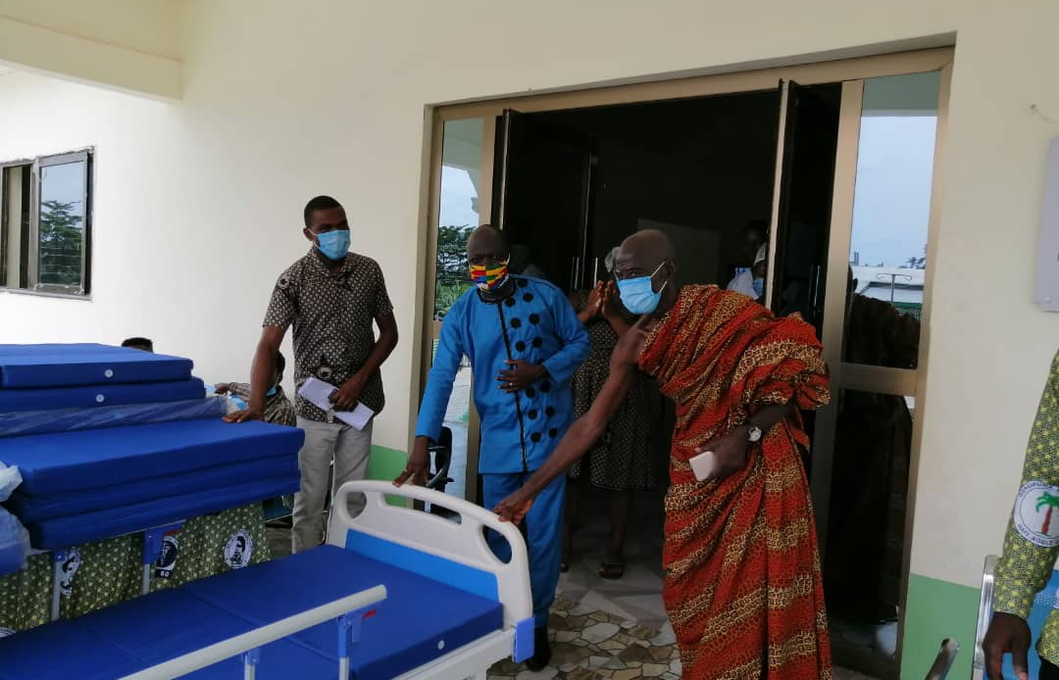

CONSTRUCTED1NO. 6UNIT CLASSROOM BLOCK @ BRADA TORNU

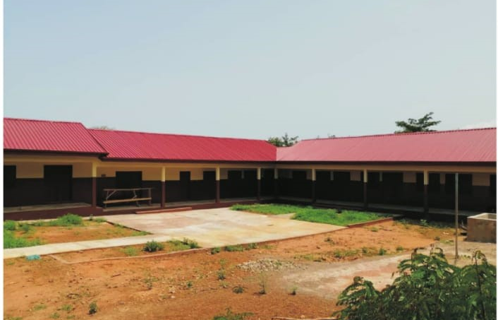

CONSTRUCTED ART GALLERY @ VAKPO
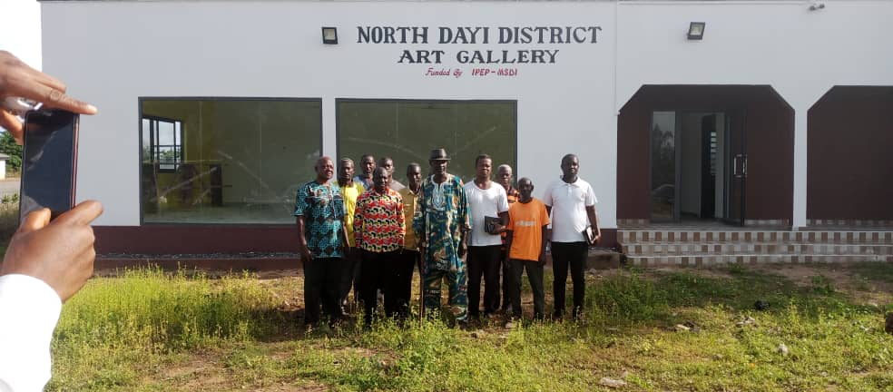

LORRY PARK @ ANFOEGA
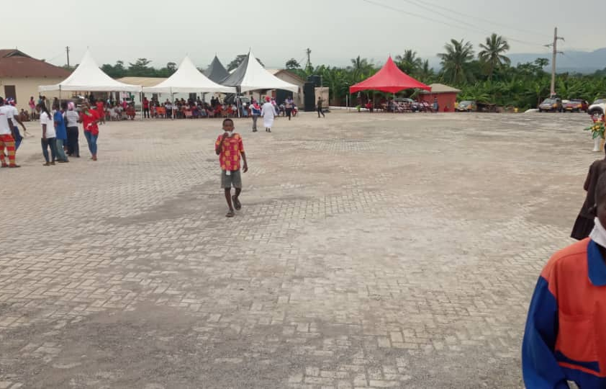

Water Project at Anfoega Adame

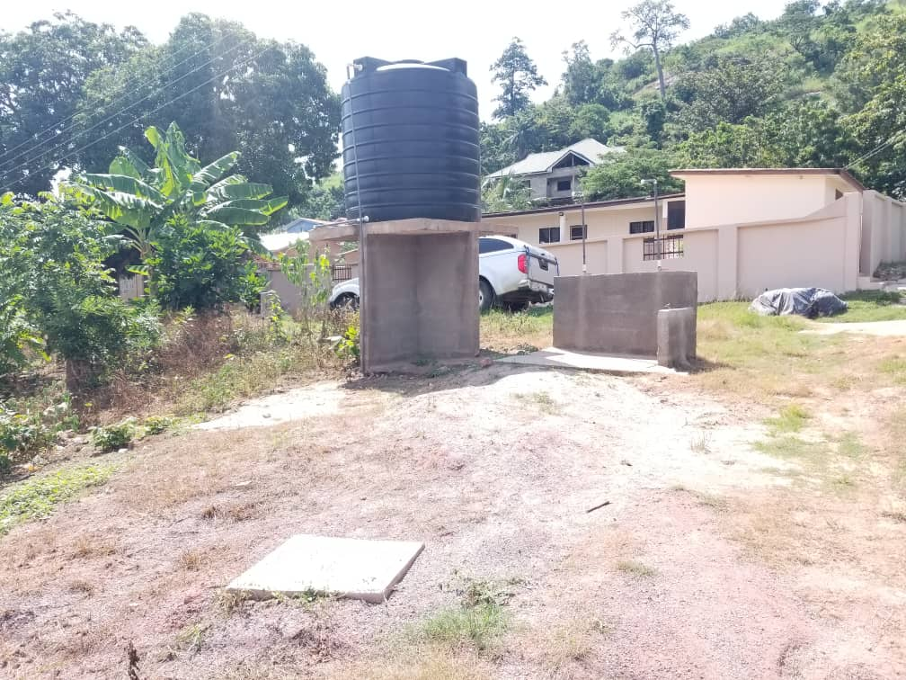

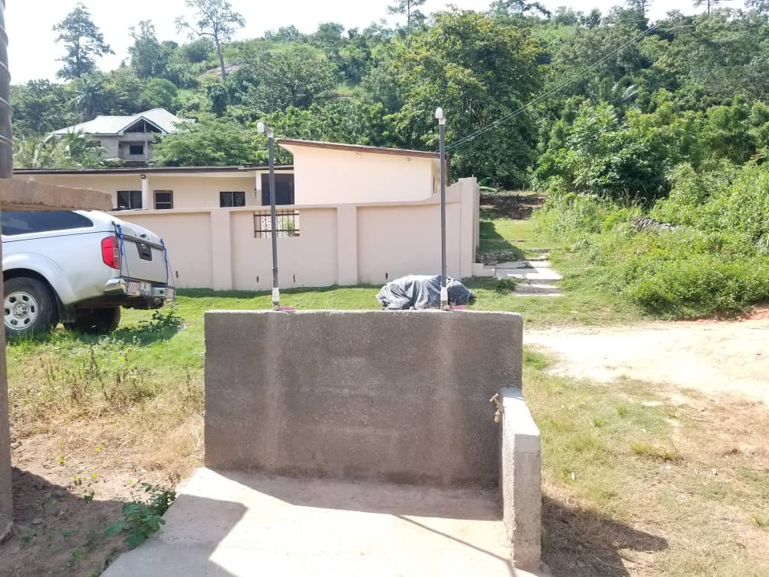

Revenue and Expenditure Performance
The North Dayi Assembly revenue can be categorized under three board heads namely internally Generated fund (IGF), Central Government transfers and donor funds.
How well each of the revenue sources and expenditure lines of the assembly performs impact the implementation of the development plan of the district.

Revenue
Table 1: Revenue Performance – IGF Only
Revenue Performance – IGF Only
Item | 2019 |  | 2020 |  | 2021 [Actual & Perf. As at July.
Item | Budget | Actual | Budget | Actual | Budget | Revised Budget | Actual | As% of total revised budget
Property Rates | 80,000.00 | 11,616.06 | 70,000.00 | 10,264.83 | 72,000.00 | 72,000.00 | 7,052.00 | 9.79
Other Rates |  |  |  |  | 5,000.00 | 5,000.00 | 91.00 | 1.82
Land | 36,613.08 | 44,557.48 | 65,400.00 | 54,196.67 | 67,940.00 | 62,940.00 | 34,950.00 | 55.53
Rent | 24,200.00 | 5,760.00 | 7,000.00 | 7,747 | 7,700.00 | 18,000.00 | 8,195.00 | 45.53
Licenses | 71,600.38 | 60,444.00 | 68,464.00 | 33,966 | 66,310.04 | 56,010.04 | 11,825.00 | 21.11
Fees | 35,273.43 | 71,536.10 | 70,800.00 | 79,089.11 | 83,800.00 | 83,800.00 | 45,767.00 | 54.61
Fines | 2,200.00 | 6,982.00 | 6,200.00 | 6,600 | 13,900.36 | 13,900.36 | 957.00 | 6.88
Investment | - | 62,266.87 | 12,000.00 | 8,636.76 | 13,200.00 | 13,200.00 | 242.87 | 1.84
Total | 249,886.89 | 263,162.51 | 299,864.00 | 200,500.37 | 329,850.40 | 329,850.40 | 109,080.37 | 33.07

Table 2: Revenue Performance – All Revenue Sources

Revenue Performance – All Revenue Sources
Item | 2019 |  | 2020 |  |  | 2021 [Actual & Perf. As at July.
Item | Budget | Actual | Budget | Revised | Actual |  | Budget | Revised budget | Actual | %
IGF | 249,886.88 | 263,162.51 | 299,864.00 | 299,864.00 | 200,500.37 |  | 329,850.00 | 329,850.00 | 109,080.37 | 33.07
Compensation | 986,192.47 | 739,645.11 | 808,819.00 | 1,356,968.68 | 1,017,759.34 |  | 1,407,184.00 | 1,407,184.00 | 863,305.85 | 61.35
GoG – G&S | 59,816.88 | 11,498.28 | 64,549.00 | 64,549.00 | 50,637.51 |  | 73,725.00 | 73,725.00 | 76,613.90 | 103.92
DACF–Assembly | 3,412,222.15 | 2,088,906.10 | 4,338,944.00 | 4,338,944.00 | 971,380.91 |  | 4,338,944.00 | 4,338,944.00 | 298,183.55 | 6.87
DACF – MP | 300,000.00 | 362,384.68 | 400,000.00 | 400,000.00 | 262,042.00 |  | 400,000.00 | 400,000.00 | 122,781.68 | 30.70
DACF-RFG | 1,012,619.00 | 1,341,416.81 | 595,153.00 | 595,153.00 | 595,489 |  | 865,396.00 | 865,396.00 | 594,462.00 | 68.69
MAG/CIDA | 130,292.85 | 130,292.95 | 130,293.00 | 130,293.00 | 130,293 |  | 96,900.00 | 96,900.00 | 42,712.30 | 44.08
UNICEF-RBF | 80,000.00 | 63,545.62 | 131,287.00 | 131,287.00 | 30,000 |  | 181,287.00 | 181,287.00 | - | -
GPSNP | - | - | 987,767.00 | 987,767.00 | - |  | 987,766.00 | 987,766.00 | 29,366.00 | 2.97
Total | 6,231,661.23 | 5,000,852.06 | 7,756,676.00 | 8,327,161.68 | 3,172,523.30 |  | 8,681,052.00 | 8,681,052.00 | 2,136,505.65 | 24.61

Expenditure
Table 3: Expenditure Performance-All Sources
EXPENDITURE PERFORMANCE (ALL DEPARTMENTS) ALL FUNDING SOURCES
Expenditure | 2019 |  | 2020 |  |  | 2021 |  |  | % Performance (as at July, 2021)
Expenditure | Budget | Actual | Budget | revised | Actual | Budget | Revised Budget | Actual as at July, 2021
Compensation | 1,051,193.47 | 835,036.67 | 877,819.00 | 1,090,740.93 | 1,090,740.93 | 1,486,000.00 | 1,486,000.00 | 882,735.54 | 59.40
Goods and Service | 2,577,285.38 | 2,221,774.07 | 3,221,148.00 | 3,251,148 | 1,105,823.72 | 3,554,483.00 | 3,554,483.00 | 493,694.26 | 13.89
Assets | 2,603,283.38 | 1,431,933.03 | 3,657,709.00 | 3,617,709 | 765,145.25 | 3,640,569.00 | 3,640,569.00 | 377,641.45 | 10.37
Total | 6,231,662.23 | 4,488,743.77 | 7,756,676.00 | 8,327,161.68 | 2,961,709.90 | 8,681,052.00 | 8,681,052.00 | 1,754,071.25 | 20.21

Adopted Medium Term National Development Policy Framework (MTNDPF) Policy Objectives
Ensure improved fiscal performance and sustainability
Ensure free equitable and quality education for all by 2030
Achieve universal health including financial risk protection, Access to quality health-care service
Universal access to safe drinking water by 2030
Support and strengthen local communities in water and sanitation management
Implement appropriate social protection system and measures

Policy Outcome Indicators and Targets
Table 4: Policy Outcome Indicators and Targets
Outcome Indicator Description | Unit of Measure | Baseline  2019 |  | Past Year 2020 |  | Latest Status 2021 |  | Medium Term Target
Outcome Indicator Description | Unit of Measure | Target | Actual | Target | Actual | Target | Actual as at July | 2022 | 2023 | 2024 | 2025
Child rights improved | No. of child maintenance cases reported and resolved | 22 | 22 | 29 | 13 | 29 | 8 | 25 | 20 | 10 | 5
Women livelihood improved | No. of women groups trained | 5 | 3 | 3 | 2 | 2 | 3 | 3 | 3 | 3 | 3
Livelihood of PWDs improved | No. of PWDs supported | 50 | 50 | 50 | 47 | 50 | 47 | 60 | 60 | 60 | 60
Improved road transport& infrastructure | No. of km of road reshaped | 15 | 15 | 15 | 3.5 | 3.5 | - | 10 | 10 | 10 | 10
General Assembly meetings organised | No. of General Assembly meetings minutes | 4 | 4 | 4 | 4 | 4 | 2 | 4 | 4 | 4 | 4
Quarterly Budget Committee meeting organised | No. of Budget committee meeting minutes | 4 | 4 | 4 | 4 | 4 | 2 | 4 | 4 | 4 | 4

Revenue Mobilization Strategies
The Assembly projected an amount of Three Hundred and Forty-One Thousand, Three Hundred and Seventy Two Ghana Cedis [GHS 341,372.00] to be collected in the 2022 Fiscal Year. The table below denotes the various strategies to be implemented to achieve the set target;
SN | Revenue Sources | Key Strategies
1. | Rates | - Carry out Public Education and Sensitization in all communities within the district to create awareness.  - Carry out Street Naming & Property Addressing systems to improve accessibility of rateable properties in the district.  - Collect data and bill all new properties not on current valuation list  - Resource area council staff to improve Basic rate collection within their jurisdiction.  - Use of Software to enhance efficiency.
2. | Lands | - Carry out Public Education and Sensitization in all communities within the district to create awareness  - Resource the works department to speed up approval of building permits  - All buildings in the district without permit will have to regularised
3. | Licenses | - Carry out Public Education and Sensitization in all communities within the district to create awareness  - Resource all relevant units within the Assembly to identify new business and improve on collection.
4. | Rent | - Timely issuance of Bills to all tenants of all properties of the Assembly as well as demand notices to pay their rents promptly.  - Use of standardized Tenancy Agreement as a bidding document for all tenants
5. | Fees | - Carry out Public Education and Sensitization in all communities within the district most especially market centre to create awareness  - Resource revenue collectors as well as zone them for effective collection of revenue.
6. | Fines | - Gazette Bye-Laws to enforce all bye-laws of the Assembly.  - Carry out Public Education and Sensitization in all communities within the district to create awareness.

PART B: BUDGET PROGRAMME/SUB-PROGRAMME SUMMARY

PROGRAMME 1: MANAGEMENT AND ADMINISTRATION
Budget Programme Objectives
- Deepen political and administrative decentralization
- Mobilize additional financial resources for development
- Improve decentralized planning

Budget Programme Description
The Programme seeks to perform the core functions of ensuring good governance and balanced development of the District through the participation of the citizenry in the formulation and implementation of policies, planning, coordination, monitoring, evaluation and mobilisation of additional financial resources for development.

The Programme is being implemented and delivered through the offices of the Central Administration, Statistics, Human Resource, Works, Physical planning and Finance Departments. The various units involved in the delivery of the Programme include; General Administration Unit, Budget Unit, Planning Unit, Environmental Unit, Procurement Unit, , Internal Audit and Records Unit.

The total staff strength of thirty-four (34) is involved in the delivery of the Programme. They include Administrators, Budget Analysts, Accountants, Planning Officers, Revenue Officers, and other support staff (i.e. Executive officers, and drivers). The Programme is being funded through the Assembly’s Composite Budget with Internally Generated Fund (IGF) and Government of Ghana transfer such as the District Assemblies’ Common Fund (DACF) and District Assemblies’ Common Fund – Responsiveness Factor Grant (DACF-RFG).

SUB-PROGRAMME 1.1 General Administration
Budget Sub-Programme Objective
- To provide administrative support and ensure effective coordination of the activities of the various departments and quasi institutions under the District Assembly.
- To ensure the effective functioning of all the sub-structures to deepen the decentralization process

Budget Sub- Programme Description
The General Administration Sub-Programme looks at the provision of administrative support and effective coordination of the activities of the various departments through the Office of the District Co-ordinating Director. The sub-Programme is responsible for all activities and Programmes relating to general services, internal controls, procurement/stores, transport, public relation and security.
The core function of the General Administration unit is to facilitate the Assembly’s activities with the various departments, quasi institution, and traditional authorities and also mandated to carry out regular maintenance of the Assembly’s properties. In addition, the District Security Committee (DISEC) is mandated to initiate and implement Programmes and strategies to improve public security in the District.
Under this sub-Programme the procurement processes of Goods and Services and Assets for the Assembly and the duty of ensuring inventory and stores management is being led by the Procurement/Stores Unit.
The number of staff delivering the sub-Programme is twenty-three (23) with funding from GoG transfers (DACF, DACF - RFG etc.) and the Assembly’s Internally Generated Fund (IGF). Beneficiaries of this sub-Programme are the departments, Regional Coordinating Council, quasi institutions, traditional authorities, non-governmental organizations, civil society organizations and the general public. The main challenges this sub Programme will encounter are inadequate, delay and untimely release of funds, inadequate mobilized internally generated funds, inadequate office space, and non-decentralization of some key departments.

Table 5: Budget Sub-Programme Results Statement

Main Outputs | Output Indicators | Past Years |  | Projections
 |  | 2020 | 2021 as at July | 2022 | 2023 | 2024 | 2025
Management Meetings Organized | No. of Management Meetings Held | 4 | 2 | 4 | 4 | 4 | 4
Response to public complaints | No. of working days complaint responded to | 5 | 2 | 5 | 5 | 5 | 5
Procurement Processes Complied with | No. of Entity Tender Committee Meetings Held | 4 | 4 | 4 | 4 | 4 | 4
DPCU Meetings Organized | No. of DPCU Meeting held | 4 | 2 | 4 | 4 | 4 | 4
Budget Committee meeting organized | No. of budget committee meeting held | 4 | 2 | 4 | 4 | 4 | 4

Budget Sub-Programme Standardized Operations and Projects

Table 6: Budget Sub-Programme Standardized Operations and Projects
Standardized Operations | Standardized Projects
Internal Management of Organization | Office equipment
- Payment of Utilities, Conferences/Seminars etc. | Electrical networks
- Maintenance & Repairs, T & T etc | Furniture and fittings
Procurement of Office Supplies & Consumables
- Payment of Printed Materials & Stationery
- General Cleaning Materials etc.
Information, Education & Communication
- Public Education & Sensitization
- Town Hall Meetings etc.
Official/National Celebrations
- Independence Day, World AIDS Day etc
- paration of Tender Document, Procurement Plan
Support to Traditional Authorities
- Financial Support, Donation festivals etc.
Local & International Affiliation
- NALAG Due
Citizens Participation in Local Governance
- Stakeholder’s Meeting on Fee-fixing Resolution
Manpower & Skills Development
- Staff Development & Training

SUB-PROGRAMME 1.2 Finance and Audit
Budget Sub-Programme Objective
- To insure sound financial management of the Assembly's resources.
- To ensure timely disbursement of funds and submission of financial reports.
- To ensure the mobilization of all available revenues for effective service delivery

Budget Sub- Programme Description
This sub-Programme provides effective and efficient management of financial resources and timely reporting of the Assembly finances as contained in the Public Financial Management Act, 2016 (Act 921) and Financial Administration Regulation. It also ensures that financial transactions and controls are consistent with prevailing financial and accounting policies, rules, regulations, and best practices.

The sub-Programme operations and major services delivered include: undertaking revenue mobilization activities of the Assembly; Internal Audit Operations; keep, render and publish statements on Public Accounts; keep receipts and custody of all public and trust monies payable into the Assembly’s Fund; and facilitates the disbursement of legitimate and authorized funds.

The Internal Audit Unit is authorized to spearhead the implementation of internal audit control procedures and processes to manage audit risks, detection and prevention of misstatement of facts that could lead to fraud, waste and abuse to the Assembly.
The sub-Programme is manned by eight (14) officers comprising of Accountants, Budget Analyst, Internal Auditors, Revenue Officers, and Commission collectors with funding from GoG transfers and Internally Generated Fund (IGF).
The beneficiaries of this sub - Programme are the departments, allied institutions and the general public. This sub-Programme in delivering its objectives is confronted by inadequate data on ratable items and inadequate logistics for revenue mobilization and public sensitization.

Table 7: Budget Sub-Programme Results Statement
.
Main Outputs | Output Indicators | Past Years |  | Projections
 |  | 2020 | 2021 as at July | 2022 | 2023 | 2024 | 2025
Annual Financial Statements Submitted | No. of Annual Financial Statements Submitted by | 28th Feb | 28th Feb | 28th Feb | 28th Feb | 28th Feb | 28th Feb
Monthly Financial Statements Submitted | No. of Monthly Financial Statements Submitted by | 15th | 15th | 15th | 15th | 15th | 15th
Revenue Mobilization Enhanced | % Increase in Revenue Mobilized | 25 | - | 20 | 20 | 20 | 20

Budget Sub-Programme Standardized Operations and Projects
Table 8: Budget Sub-Programme Standardized Operations and Projects
Standardized Operations
Treasury and Accounting Activities
- Purchase of Value Books, Report Submission etc.
Revenue Collection and Management
- Payment of Commission for Revenue Agents etc.
Internal Audit Operations
- Audit Committee Meetings, Report Submission etc.

SUB-PROGRAMME 1.3 Human Resource Management
- To ensure staffing gaps are filled with qualified officers
- To ensure staff capacity is built to perform task efficiently and effectively

Budget Sub- Programme Description
This sub-programme will access staff gaps and capacity building needs of officers, coordinate the performance appraisal in the entire departments and units, prepare the annual leave roster of North Dayi District Assembly.

The number of staff delivering the sub-Programme is one (1) with funding from GoG transfers (DACF, DACF - RFG etc.) and the Assembly’s Internally Generated Fund (IGF). Beneficiaries of this sub-Programme are the officers in the departments and units.

Table 9: Budget Sub-Programme Results Statement
Main Outputs | Output Indicators | Past Years |  | Projections
 |  | 2020 | 2021 as at July | 2022 | 2023 | 2024 | 2025
Monthly HR report submitted | No. of HRMIS report | 12 | 6 | 12 | 12 | 12 | 12
Capacity building of officers | No. of report on capacity building of officers | 4 | 2 | 4 | 4 | 4 | 4

Budget Sub-Programme Standardized Operations and Projects

Table 10: Budget Sub-Programme Standardized Operations and Projects
Standardized Operations
Staff training and skills development
Procurement of office equipment and logistics

SUB-PROGRAMME 1.4 Planning, Budgeting, Coordination and Statistics
Budget Sub-Programme Objective
- To ensure the collation of the developmental plan of the sub-structures and various departments
- Composite programme based budget prepared from the developmental plans, implemented and monitored
- To ensure accurate data exist by regular updating

Budget Sub- Programme Description
The sub-Programmes coordinate data collection, policy formulation, preparation and implementation of the District Medium Term Development Plan, Monitoring and Evaluation Plan as well as the Composite Budget of the District Assembly. Two (2) units and one(1) department ie Planning, Budget Unit and statistical department will be responsible for this sub-Programme.

- Preparing and reviewing District Medium Term Development Plans, M & E Plans, and Annual Budgets.
- Managing the budget approved by the General Assembly and ensuring that each Programme/project uses the budget resources allocated in accordance with their mandate.
- Co-ordinate and develop annual action plans, monitor and evaluate Programmes and projects
- Periodic monitoring and evaluation of entire operations and projects of the Assembly to ensure compliance of rules, value for money and enhance performance.
- Organizing stakeholder meetings, public forum and town hall meeting.

Seven (7) officers will be responsible for delivering the sub-Programme comprising of Senior Budget Analyst, Assistant Budget Analysts, Assistant Budget Officers, Planning Officers and statistical officer. The main funding source of this sub-Programme is GoG transfer and the Assembly Internally Generated Funds. Beneficiaries of this sub- Programme are the departments, allied institutions and the general public.
Challenges hindering the efforts of this sub-Programme include inadequate office space for Budget unit, inadequate data on ratable items and inadequate logistics for public education and sensitization.

Table 11: Budget Sub-Programme Results Statement

Main Outputs | Output Indicators | Past Years |  | Projections
 |  | 2020 | 2021 as at July | 2022 | 2023 | 2024 | 2025
Composite Budget based on Composite AAP Prepared | Composite Budget based on Composite AAP approved by General Assembly | 30th Sept | 30th Sept | 30th Sept | 30th Sept | 30th Sept | 30th Sept
Social Accountability Meetings Held | No. of Public Accountability Meetings Held | 2 | 1 | 2 | 2 | 2 | 2
Monitoring & Evaluations carried out | No. of quarterly Monitoring reports submitted | 4 | 1 | 4 | 4 | 4 | 4
Stakeholder’s Consultative Meetings Held | No. of Stakeholder’s Consultative Meetings Held | 2 | 1 | 2 | 2 | 2 | 2
DPCU Meetings Organized | No. of DPCU Meetings Held | 4 | 2 | 4 | 4 | 4 | 4
Budget Committee Meetings Organized | No. of Budget Committee Meetings Held | 4 | 2 | 4 | 4 | 4 | 4

Budget Sub-Programme Standardized Operations and Projects

Table 12: Budget Sub-Programme Standardized Operations and Projects
Standardized Operations | Standardized Projects
Administrative and technical meetings | Acquisition of movable and immovable assets  - Procurement of Furniture and fittings  - Office equipment
Monitoring & Evaluation of Programmes/Projects
Internal Management of the Organisation
Procurement of office supplies and consumables

SUB-PROGRAMME 1.5 Legislative Oversights
Budget Sub-Programme Objective
To ensure full implementation of the political, administrative and fiscal decentralization reforms.
Budget Sub- Programme Description
This sub-Programme formulates appropriate specific district policies and implement them in the context of national policies. These policies are deliberated upon by its Area Councils, Sub-Committees and the Executive Committee. The report of the Executive Committee is eventually considered, approved and passed by the General Assembly into lawful district policies and objectives for the growth and development of the district.
The office of the Honourable Presiding Member spearheads the work of the Legislative Oversight role and ably assisted by the Office of the District Coordinating Director. The main unit of this sub-Programme is the Area Councils, Office of the Presiding Member and the Office of the District Coordinating Director.
The activities of this sub-Programme are financed through the IGF, and DACF funding sources available to the Assembly. The beneficiaries of this sub-Programme are the Area Councils, local communities and the general public.
Efforts of this sub-Programme are however constrained and challenged by the inadequate logistics to the Area Councils of the Assembly.

Table 13: Budget Sub-Programme Results Statement
Main Outputs | Output Indicators | Past Years |  | Projections
 |  | 2020 | 2021 as at July | 2022 | 2023 | 2024 | 2025
Statutory Meetings Organized | No. of General Assembly Held | 4 | 2 | 4 | 4 | 4 | 4
Statutory Meetings Organized | No. of Sub Committee Meetings Held | 4 | 2 | 4 | 4 | 4 | 4
Area Council Staff Trained | No. of Training Workshop Organized | 2 | 2 | 2 | 2 | 2 | 2

Budget Sub-Programme Standardized Operations and Projects
Table 14: Budget Sub-Programme Standardized Operations and Projects
Standardized Operations | Standardized Projects
Legislative Enactment and Oversight
- General Assembly, Sub_Committe Meetings, etc.

PROGRAMME 2: SOCIAL SERVICES DELIVERY
Budget Programme Objectives
- To formulate and implement policies on Education in the District within the framework of National Policies and guidelines.
- To formulate, plan and implement district health policies within the framework of national health policies and guidelines provided by the Minister of Health.
- To accelerate the provision of improved environmental sanitation service.
- To assist the Assembly to formulate and implement social welfare and community development policies within the framework of national policy.
- To attain universal births and deaths registration in the District.

Budget Programme Description
The Social Service Delivery Programme seeks to harmonize the activities and functions of the following agencies; Ghana Education Service, Youth Employment Authority and Youth Authority operating at the district level.
To improve Health and Environmental Sanitation Services, the Programmes aims at providing facilities, infrastructural services and Programmes for effective and efficient waste management for the environmental sanitation, the protection of the environment and the promotion of public health.
The Programme also intends to make provision for community care services including social welfare services and street children, child survival and development.
The Birth and Death Registry seeks to provide accurate, reliable and timely information of all births and deaths occurring within the District for socio-economic development through their registration and certification.

The various organization units involved in the delivery of the Programme include; Ghana Education Service, District Health Services, Environmental Health Unit, Social Welfare & Community Development Department and Birth & Death Registry.
The funding sources for the Programme include GoG transfers and Internally Generated Funds from of the Assembly. The beneficiaries of the Programme include urban and rural dwellers in the District. Total staff strength of twenty-three (23) from the Social Welfare & Community Development Department and Environmental Health Unit with support from staff of the Ghana Education Service, Ghana Health Service who are schedule 2 departments is delivering this Programme

SUB-PROGRAMME 2.1 Education, Youth and Sports Services
Budget Sub-Programme Objective
- To formulate and implement policies on Education in the District within the framework of National Policies and guidelines.
- Increase access to education through school improvement.
- To improve the quality of teaching and learning in the District.
- Ensuring teacher development, deployment and supervision at the basic level.
- Promoting entrepreneurship among the youth.

Budget Sub- Programme Description
The Education and Youth Development sub-Programme is responsible for pre-school, special school, basic education, youth and sports development or organization and library services at the District level. Key sub-Programme operations include;
- Advising the North Dayi District Assembly on matters relating to preschool, primary, junior high schools in the district and other matters that may be referred to it by the District Assembly.
- Facilitate the supervision of pre-school, primary and junior high schools in the District
- Co-ordinate the organization and supervision of training Programmes for youth in the district to develop leadership qualities, personal initiatives, patriotism and community spirit.
- Advise on the provision and management of public libraries and library services in the district in consultation with the Ghana Library Board.
- Advise the Assembly on all matters relating to sports development in the District.

Organizational units delivering the sub-Programme include the Ghana Education Service, District Youth Authority, Youth Employment Agency (YEA) and Non-Formal Department with funding from the GoG and Assembly’s Internally Generated Funds.

Major challenges hindering the success of this sub-Programme includes inadequate staffing level, delay and untimely release of funds, inadequate office space and logistics. Beneficiaries of the sub-Programme are urban and rural dwellers in the District.

Table 15: Budget Sub-Programme Results Statement
Main Outputs | Output Indicators | Past Years |  | Projections
 |  | 2020 | 2021 as at July | 2022 | 2023 | 2024 | 2025
Educational Infrastructure Improved | No. of Classroom Blocks Constructed | 1 | 1 | 3 | 3 | 3 | 3
Educational Logistics Improved | No. of School Furniture Supplied | 326 | 150 | 400 | 300 | 300 | 350
DEOC Quarterly Meetings Organized | No. of DEOC quarterly Meetings Held | 3 | 2 | 4 | 4 | 4 | 4
Tuition Fees paid to Students | No. of Student’s Tuition fees paid | 32 | 20 | 50 | 50 | 50 | 60

Budget Sub-Programme Standardized Operations and Projects

Table 16: Budget Sub-Programme Standardized Operations and Projects
Standardized Operations | Standardized Projects
Supervision & Inspection of Education Delivery | Acquisition of Movable and immovable Assets
- Support for training of Circuit Supervisors | - Construction of 1No. 3-Unit classroom Block
Support to Teaching & Learning | - Construction of 1 No. 3-Unit classroom Block
- Payment of Tuition fees, Award schemes | - Construction of 1 No. 2 – Unit KG Block
Development of Youth, Sport & Culture | - Construction of 1 No. 3-Unit classroom Block
- Support to inter-school sports & Culture | Procurement of 200 No. Mono and 200 No. Dual Desk
Maintenance, Refurbishment, Rehabilitation

SUB-PROGRAMME 2.2 Public Health Services and Management
Budget Sub-Programme Objective
- The main objective of this sub-Programme is to formulate, plan and implement district health policies within the framework of national health policies and guidelines provided by the Minister of Health
- Ensure good quality health delivery in the district
- Ensure decrease in maternal mortality delivery

Budget Sub- Programme Description
The sub-Programme aims at providing facilities, infrastructural services and Programmes for effective and efficient promotion of public and environmental health in the District. Public Health aims at delivering public, family and child health services directed at preventing diseases and promoting the health of all people living in the District. It also seeks to coordinate the works of health centers or posts or community-based health workers and facilitates collection and analysis of data on health. In addition, emphasis will be placed on supporting high-risk groups to prevent the spread of HIV/AIDS, TB, and Malaria among others.
The Environmental Health aims at facilitating improved environmental sanitation and good hygiene practices in both rural and urban dwellers in the District. It provides, supervises and monitors the execution of environmental health and environmental sanitation services. It also aims at empowering individuals and communities to analyse their sanitation conditions and take collective action to change their environmental sanitation situation. The sub-Programme operations include;
- Advising the Assembly on all matters relating to health including diseases control and prevention.
- Undertaking health education and family immunization and nutrition Programmes.
- Preventing new transmission, including awareness creation, direct service delivery and supporting high risk groups.
- Providing support for people living with HIV/AIDS (PLWHA) and their families.
- Inspection of meat, fish, vegetables and other foodstuff and liquids of whatever kind or nature, whether intended for sale or not and to seize, destroy and otherwise deal with such foodstuff or liquids as are unfit for human consumption.
- Supervise and control slaughter houses and pounds and all such matters and things as may be necessary for the convenient use of such slaughter houses.
- Advise and encourage the keeping of animals in the district including horses, cattle, sheep and goats, domestic pets and poultry.
The sub-Programme would be delivered through the offices of the District Health Directorate and the Environmental Health Unit with a total staff strength of fourteen (14). Funding for the delivery of this sub-Programme would come from GoG transfers, Donor Support and Internally Generated Funds. The beneficiaries of the sub-Programme are the various health facilities and entire citizenry in the district.
Challenges militating against the success of this sub-Programme include delay and untimely release of funds from central government, inadequate staffing levels, inadequate office space, inadequate equipment and logistics to health facilities.

Table 17: Budget Sub-Programme Results Statement
Main Outputs | Output Indicators | Past Years |  | Projections
 |  | 2020 | 2021 as at July | 2022 | 2023 | 2024 | 2025
Access to health services delivery improved | No. of Function Health Facilities Constructed | 1 | 1 | 2 | 2 | 2 | 2
Maternal & Child Health Improved | No. of Community durbars on ANC, PNC, Safe delivery | 30 | 30 | 50 | 50 | 50 | 50

Budget Sub-Programme Standardized Operations and Projects

Table 18: Budget Sub-Programme Standardized Operations and Projects
Standardized Operations | Standardized Projects
Public Health Services | Acquisition of movable and immovable Asset
- Public Education, Health Suitability expenses | - Construction of 1 No. CHPS Compound
Covid – 19 Related reliefs | - Construction of 1 No. CHPS Compound
Procurement of medical supplies etc | - Construction of weighing sheds

SUB-PROGRAMME 2.3 Social Welfare and Community Development
Budget Sub-Programme Objective
The objective of the sub-Programme is to assist the Assembly to formulate and implement social welfare and community development policies within the framework of national policy.
Budget Sub- Programme Description
The Social Welfare and Community Development department is responsible for this sub-Programme. Basically, Social Welfare aims at promoting and protection of rights of children, seek justices and administration of child related issues and provide community care for disabled and needy adults.

Community Development is also tasked with the responsibility of promoting social and economic growth in the rural communities through popular participation and initiatives of community members in activities of poverty alleviation, employment creation and illiteracy eradication among the adult and youth population in the rural and urban poor areas in the District. Major services to be delivered include;
- Facilitating community-based rehabilitation of persons with disabilities.
- Assist and facilitate provision of community care services including registration of persons with disabilities, assistance to the aged, personal social welfare services, and assistance to street children, child survival and development, socio-economic and emotional stability in families.
- Assist to organize community development Programmes to improve and enrich rural life through literacy and adult education classes, voluntary contribution and communal labour for the provision of facilities and services such as water, schools, library, community centres and public places of convenience.

This sub Programme is undertaken with a total staff strength of six (6) with funds from GoG transfers (PWD Fund), DACF and Assembly’s Internally Generated Funds. Challenges facing this sub-Programme include untimely release of funds and logistics for public education.

Table 19: Budget Sub-Programme Results Statement
Main Outputs | Output Indicators | Past Years |  | Projections
 |  | 2020 | 2021 as at July | 2022 | 2023 | 2024 | 2025
PWDs supported to engage in Economic Activities | No. of PWDs Supported | 21 |  | 70 | 70 | 70
Child Maintenance cases Handled | No. of issues resolved | 13 |  | 18 | 18 | 18
LEAP Payments carried out | No. of beneficiary households | 609 |  | 609 | 609 | 609
Community Sensitizations on Child Right Promotion & Protection Carried out | No. of Comm. Sensitized | 27 |  | 30 | 30 | 30

Budget Sub-Programme Standardized Operations and Projects

Table 20: Budget Sub-Programme Standardized Operations and Projects
Standardized Operations | Standardized Projects
Internal Management of Organization
- Payment of Utilities, Conferences/Seminars etc.
Procurement of Office Supplies & Consumables
- Payment of printed materials & Stationery etc.
Information, Education and Communication
- Public Education & Sensitization etc.
Social Intervention Programmes
- Support to PWDs, LEP expenses etc
Community Mobilization
- Community Entry Expenses, Focus Group Expend.
Child Right Promotion & Protection
- Child abuse and Maintenance Expenses
Gender Empowerment & Mainstreaming
- Public Education to vulnerable groups
Combating Domestic Violence & Human Trafficking
- Sensitization on Good Parental Care Expenses

SUB-PROGRAMME 2.5 Environmental Health and Sanitation Services
Budget Sub-Programme Objective
- Ensure clean environment in district
- Ensure the refuse disposal sites maintain
- Ensure food and drinks vendors are screen health wise

Budget Sub- Programme Description
The sub-Programme aims at providing facilities, infrastructural services and Programmes for effective and efficient promotion of public and environmental health in the District. Public Health aims at delivering public, family and child health services directed at preventing diseases and promoting the health of all people living in the District. It also seeks to coordinate the works of health centers or posts or community-based health workers and facilitates collection and analysis of data on health. In addition, emphasis will be placed on supporting high-risk groups to prevent the spread of HIV/AIDS, TB, and Malaria among others.
The Environmental Health aims at facilitating improved environmental sanitation and good hygiene practices in both rural and urban dwellers in the District. It provides, supervises and monitors the execution of environmental health and environmental sanitation services. It also aims at empowering individuals and communities to analyse their sanitation conditions and take collective action to change their environmental sanitation situation. The sub-Programme operations include;
- Advising the Assembly on all matters relating to health including diseases control and prevention.
- Undertaking health education and family immunization and nutrition Programmes.
- Preventing new transmission, including awareness creation, direct service delivery and supporting high risk groups.
- Providing support for people living with HIV/AIDS (PLWHA) and their families.
- Inspection of meat, fish, vegetables and other foodstuff and liquids of whatever kind or nature, whether intended for sale or not and to seize, destroy and otherwise deal with such foodstuff or liquids as are unfit for human consumption.
- Supervise and control slaughter houses and pounds and all such matters and things as may be necessary for the convenient use of such slaughter houses.
- Advise and encourage the keeping of animals in the district including horses, cattle, sheep and goats, domestic pets and poultry.
The sub-Programme would be delivered through the offices of the District Health Directorate and the Environmental Health Unit with a total staff strength of fourteen (14). Funding for the delivery of this sub-Programme would come from GoG transfers, Donor Support and Internally Generated Funds. The beneficiaries of the sub-Programme are the various health facilities and entire citizenry in the district.
Challenges militating against the success of this sub-Programme include delay and untimely release of funds from central government, inadequate staffing levels, inadequate office space, inadequate equipment and logistics to health facilities

Table 23: Budget Sub-Programme Results Statement
Main Outputs | Output Indicators | Past Years |  | Projections
 |  | 2020 | 2021 as at July | 2022 | 2023 | 2024 | 2025
Sanitation Coverage Improved | No. of Communities Declared ODF | 4 | - | 10 | 10 | 10 | 10
Sanitation Coverage Improved | % of Population served with safe water | 87 | 87 | 97 | 98 | 99 | 100
Health screening | No. of vendors screen | 1250 | 1350 | 1500 | 1500 | 1500 | 1500

Budget Sub-Programme Standardized Operations and Projects

Table 24: Budget Sub-Programme Standardized Operations and Projects
Standardized Operations | Standardized Projects
Public Education and sensitisation
Stay animal arrest
Food vendors health screening
Monitoring and supervision

PROGRAMME 3: INFRASTRUCTURE DELIVERY AND MANAGEMENT
Budget Programme Objectives
- To implement development Programmes to enhance rural transport through improved feeder and farm to market road network.
- To improve service delivery to ensure quality of life in rural areas.
- To accelerate the provision of affordable and safe water

Budget Programme Description
The sub-Programme is tasked with the responsibility of developing and implementing appropriate strategies and Programmes that aims to improve the living conditions of rural dwellers. Under this sub-Programme reforms including feeder road construction and rehabilitation as well as rural housing and water Programmes are adequately addressed. The department of Works comprising of former Public Works, Feeder Roads, and Physical Planning Department are delivering the sub-Programme. The sub-Programme operations include;
- Facilitating the implementation of policies on works and report to the Assembly
- Assisting to prepare tender documents for all civil works projects to be undertaken by the Assembly through contracts or community-initiated projects.
- Facilitating the construction, repair and maintenance of public buildings, roads including feeder roads and drains along any streets in the major settlements in the District.
- Facilitating the provision of adequate and wholesome supply of potable water for the entire District.
- Assisting in the inspection of projects undertaken by the North Dayi District Assembly with relevant Departments of the Assembly.
- Provide technical and engineering assistance on works undertaken by the Assembly.
- Ensure the implementation of development control plans
- Ensure building plans are approved by the spatial and technical committees

This sub Programme is funded from the Central Government transfers and Assembly’s Internally Generated Funds which goes to the benefit of the entire citizenry in the District. The sub-Programme is managed by three (5) staff. Key challenges encountered in delivering this sub-Programme include inadequate staffing levels, logistics and officers abuse physically and verbally in the performance of their duty.

SUB-PROGRAMME 3.1 Physical and Spatial Planning Development
Budget Sub-Programme Objective
- Ensure the implementation of development control plans
- Ensure building plans are approved by the spatial and technical committees

Budget Sub- Programme Description
The sub-Programme is tasked with the responsibility of developing and implementing appropriate strategies, Programmes and development / spatial plans that aims to improve the living conditions of rural dwellers
This sub Programme is funded from the Central Government transfers (DACF andGoG) and Assembly’s Internally Generated Funds which goes to the benefit of the entire citizenry in the District
The sub-Programme is managed by one (1) staff.
Key challenges encountered in delivering this sub-Programme include inadequate staffing levels and logistics

Table 25: Budget Sub-Programme Results Statement
Main Outputs | Output Indicators | Past Years |  | Projections
 |  | 2020 | 2021 as at July | 2022 | 2023 | 2024 | 2025
Spatial and technical committee meeting help | No. of meeting minutes | 12 | 6 | 12 | 12 | 12 | 12
Building plan approved | Report on plan received and approved | 50 | 20 | 50 | 60 | 60 | 60

Budget Sub-Programme Standardized Operations and Projects

Table 26: Budget Sub-Programme Standardized Operations and Projects
Standardized Operations | Standardized Projects
Administrative and technical meeting | Procurement of office logistics
Monitoring and supervision | Procurement of development/spatial plan
Street naming and property addressing | Procurement of street naming signages

SUB-PROGRAMME 3.2 Public Works, Rural Housing and Water Management
Budget Sub-Programme Objective
- To implement development Programmes to enhance rural transport through improved feeder and farm to market road network.
- To improve service delivery to ensure quality of life in rural areas.
- To accelerate the provision of affordable and safe water

Budget Sub- Programme Description
The sub-Programme is tasked with the responsibility of developing and implementing appropriate strategies and Programmes that aims to improve the living conditions of rural dwellers. Under this sub-Programme reforms including feeder road construction and rehabilitation as well as rural housing and water Programmes are adequately addressed. The department of Works comprising of former Public Works, Feeder Roads, and Rural Housing Department is delivering the sub-Programme. The sub-Programme operations include;
- Facilitating the implementation of policies on works and report to the Assembly
- Assisting to prepare tender documents for all civil works projects to be undertaken by the Assembly through contracts or community-initiated projects.
- Facilitating the construction, repair and maintenance of public buildings, roads including feeder roads and drains along any streets in the major settlements in the District.
- Facilitating the provision of adequate and wholesome supply of potable water for the entire District.
- Assisting in the inspection of projects undertaken by the North Dayi District Assembly with relevant Departments of the Assembly.
- Provide technical and engineering assistance on works undertaken by the Assembly.

This sub Programme is funded from the Central Government transfers and Assembly’s Internally Generated Funds which goes to the benefit of the entire citizenry in the District. The sub-Programme is managed by three (4) staff. Key challenges encountered in delivering this sub-Programme include inadequate staffing levels, logistics and officers abuse physically and verbally in the performance of their duty.

Table 27: Budget Sub-Programme Results Statement
Main Outputs | Output Indicators | Past Years |  | Projections
 |  | 2020 | 2021 as at July | 2022 | 2023 | 2024 | 2025
Project supervision carried out | No. of Projects Supervised | 12 | 3 | 14 | 14 | 14 | 14
Development Control enforced | No. of reports on site visits | 18 | 6 | 20 | 20 | 20 | 20
Statutory Meetings Held | No. of Works Sub Committee Meetings Held | 4 | 2 | 4 | 4 | 4 | 4
 | No. of Project Site Meetings | 18 | 6 | 20 | 20 | 20 | 20
Road Transport Improved | No. of KM of road reshaped | 10 | - | 7 | 5 | 5 | 5

Budget Sub-Programme Standardized Operations and Projects

Table 28: Budget Sub-Programme Standardized Operations and Projects
Standardized Operations | Standardized Projects
Internal Management of Organization | Acquisition of movable and immovable asset
Procurement of Office logistics | Construction of 4 No. Boreholes
Supervision & Regulation of Infrastructural Development | Construction of 4 No. 4 Bedroom staff Bungalow
 | Construction of 3 No. culverts

PROGRAMME 4: ECONOMIC DEVELOPMENT
Budget Programme Objectives
- To provide extension services in the areas of natural resources management, and rural infrastructural and small-scale irrigation.
- To facilitate the implementation of policies on trade, industry and tourism in the District

Budget Programme Description
The Programme aims at making efforts that seeks to improve the economic well-being and quality of life for the District by creating and retaining jobs and supporting or growing incomes. It also seeks to empower small and medium scale business both in the agricultural and services sector through various capacity building modules to increase their income levels

The Programme is being delivered through the offices of the departments of Agriculture, Business Advisory Centre and Co-operatives.

The Programme is being implemented with the total support of all staff of the Agriculture department and the Business Advisory Center. Total staff strength of fourteen (14) are involved in the delivery of the Programme. The Programme is being funded through the Government of Ghana transfers with support from the Assembly’s Internally Generated Fund and other donor support funds.

SUB-PROGRAMME 4.1 Trade, Tourism and Industrial Development
Budget Sub-Programme Objective
- To facilitate the implementation of policies on trade, industry and tourism in the District
- Collect and update data on businesses in the district
- Education businesses on national support programmes

Budget Sub- Programme Description
The Business Advisory Centre under the guidance of the Assembly would deal with issues related to trade, cottage industry and tourism in the district. The Business Advisory Centre and Co-operatives are the main organizational units spearheading the sub-Programme which seeks to facilitate the implementation of policies on trade, industry and tourism in the District. It also takes actions to reduce poverty by providing training in technical and business skills, assisting in the access of low-income people to capital and bank services and assisting the creation of new jobs. The sub-Programme again seeks to improve on existing SMEs through financial assistance and managerial skill training as well as helping identify new avenues for jobs, value addition, access to market and adoption of new and improved technologies. The main sub-Programme operations include;
- Advising on the provision of credit for micro, small-scale and medium scale enterprises.
- Assisting to design, develop and implement a plan of action to meet the needs and expectations of organized groups.
- Assisting in the establishment and management of rural and small-scale industries on commercial basis.
- Promoting the formation of associations, co-operative groups and other organizations which are beneficial to the development of small-scale industries.
- Offering business and trading advisory information services.
- Facilitating the promotion of tourism in the District.

Officers of the Business Advisory Centre and Co-operatives are tasked with the responsibility of managing this sub-Programme with funding from GoG transfers and donor support which would inure to the benefit of the unemployed youth, SME’s and the general public. The service delivery efforts of the department are constrained and challenged by inadequate staff and office equipment, low interest in technical apprenticeship, transport difficulty and inadequate funding, among others

Table 31: Budget Sub-Programme Results Statement
Main Outputs | Output Indicators | Past Years |  | Projections
 |  | 2020 | 2021 as at July | 2022 | 2023 | 2024 | 2025
Advisory and Counselling services to SMEs provided | No. of SMEs Counselled | 4 | 2 | 4 | 4 | 4 | 4
SMEs Sub Committee Meetings Held | No. of SMEs Sub - Committee meetings Held | 4 | 2 | 4 | 4 | 4 | 4

Budget Sub-Programme Standardized Operations and Projects
Table 32: Budget Sub-Programme Standardized Operations and Projects
Standardized Operations | Standardized Projects
Trade Development and Promotion
- Exhibition & Trade fair expenses
Development and Promotion of Tourism Potentials
- Identification of Tourist site

SUB-PROGRAMME 4.2 Agricultural Services and Management
Budget Sub-Programme Objective
- To assist in the formulation and implementation of agricultural policy for the North Dayi District Assembly within the framework of national policies.
- To provide extension services in the areas of natural resources management, and rural infrastructural and small-scale irrigation in the District

Budget Sub- Programme Description
The department of Agriculture is responsible for delivering the Agricultural Service and Management sub-Programme. It seeks to provide effective extension and other support services to farmers, processors and traders for improved livelihood in the District. Moreover, the sub-Programme deals with identifying and disseminating improved up-to-date technological packages to assist farmers engage in good agricultural practices. Basically, it seeks to transfer improved agricultural technologies through the use of effective and efficient agricultural extension delivery methods.

The sub-Programme operations include;
- Promoting extension services to farmers.
- Assisting and participating in on-farm adaptive research.
- Lead the collection of data for analysis on cost effective farming enterprises.
- Advising and encouraging crop development through nursery propagation.
- Assisting in the development, rehabilitation and maintenance of small-scale irrigation schemes.
The sub-Programme is undertaken by fourteen (14) officers with funding from the GoG transfers, other donor supported funds and Assembly’s support from the Internally Generated Fund. It aims at benefiting the general public especially the rural farmers and dwellers. Key challenges include inadequate staffing levels, inadequate office space, untimely releases of funds and inadequate logistics for public education and sensitization.

Table 33: Budget Sub-Programme Results Statement
Main Outputs | Output Indicators | Past Years |  | Projections
 |  | 2020 | 2021 as at July | 2022 | 2023 | 2024 | 2025
Farm visits on extension services attended | No. of Farms Visited | 3840 | 1000 | 3840 | 3840 | 3840 | 3840
Increase adoption of improved technologies | No. of Farmer’s covered | 3840 | 1000 | 3840 | 3840 | 3840 | 3840

Budget Sub-Programme Standardized Operations and Projects

Table 34: Budget Sub-Programme Standardized Operations and Projects
Standardized Operations | Standardized Projects
Internal Management of Organization
- Payment of Utilities, Maintenance & Repairs
Procurement of Office Supplies & Consumables
- Payment of Stationery, Cleaning Materials
Information, Education and Communication
- Public Education & Sensitization Expenses
Official/National Celebrations
- Farmer’s Day Celebration Expenses
Extension Services
- Training of farmers expenses
Agricultural Research & Demonstration Farms
- Adaptive trial training expenses
Surveillance & Management of Diseases & Pests

PROGRAMME 5: ENVIRONMENTAL MANAGEMENT
Budget Programme Objectives
- To ensure that ecosystem services are protected and maintained for future human generations.
- To manage disasters by co-ordinating resources and developing the capacity of communities to respond effectively to disasters and improve their livelihood through social mobilization, employment generation and poverty reduction projects.

Budget Programme Description
The Environmental Management offers research and opinions on use and conservation of natural resources, protection of habitats and control of hazards. It also seeks to promote sustainable forest, wildlife and mineral resource management and utilization.
Disaster Prevention and Management Programme is also responsible for the management of disasters as well as other emergencies in the District. It seeks to enhance the capacity of society to prevent and manage disasters and to improve the livelihood of the poor and vulnerable in the rural communities through effective disaster management, social mobilization and employment generation.
Staff from NADMO and Forestry and Game Life Section of the Forestry Commission in the District is undertaking the Programme with funding from GoG transfers and Internally Generated Funds of the Assembly. The beneficiaries of the Programme include urban and rural dwellers in the District.

SUB-PROGRAMME 5.1 Disaster Prevention and Management
Budget Sub-Programme Objective
- To manage disasters by co-ordinating resources and developing the capacity of communities to respond effectively to disasters and improve their livelihood through social mobilization, employment generation and poverty reduction projects.
- Identify disaster prone areas of the district
- Strategize and educate the district on plan

Budget Sub- Programme Description
The National Disaster Management Organization (NADMO) section under the Assembly is responsible for delivering the sub-Programme. It seeks to assist in planning and implementation of Programmes to prevent and/or mitigate disaster in the District within the framework of national policies.

The sub-Programme operations include;
- To facilitate the organization of public disaster education campaign Programmes to create and sustain awareness of hazards of disaster and emphasize the role of the individual in the prevention of disaster.
- To assist and facilitate education and training of volunteers to fight fires including bush fires or take measures to manage the after effects of natural disasters.
- Prepare and review disaster prevention and management plans to prevent or control disasters arising from floods, bush fires, and human settlement fire, earthquakes and other natural disasters.
- To participate in post disaster assessment to determine the extent of damage and needs of the disaster area.
- Co-ordinate the receiving, management and supervision of the distribution of relief items in the District.
- Facilitate collection, collation and preservation of data on disasters in the District.

The sub-Programme is undertaken by officers from the NADMO section with funding from the GoG transfers and Assembly’s support from the Internally Generated Fund. The sub-Programme goes to the benefit of the entire citizenry within the District. Some challenges facing the sub-Programme include inadequate office space, untimely releases of funds and inadequate logistics for public education and sensitization.

Table 35: Budget Sub-Programme Results Statement
Main Outputs | Output Indicators | Past Years |  | Projections
 |  | 2020 | 2021 as at July | 2022 | 2023 | 2024 | 2025
Victims of Disasters Supported | No. of Victims Supported | 5 | - | 50 | 50 | 50 | 50
Reports Prepared & Submitted | No. of Quarterly Reports submitted | 4 | 2 | 4 | 4 | 4 | 4

Budget Sub-Programme Standardized Operations and Projects

Table 36: Budget Sub-Programme Standardized Operations and Projects
Standardized Operations | Standardized Projects
Disaster Management
- Disaster Education and Plan preparation

SUB-PROGRAMME 5.2 Natural Resources Conservation and Management
Budget Sub-Programme Objective
- To ensure that ecosystem services are protected and maintained for future human generations.
- To implement existing laws and regulations and Programmes on natural resources utilisation and environmental protection.
- Increase environmental protection through re-afforestation.

Budget Sub- Programme Description
The Natural Resource Conservation and Management refers to the management of natural resources such as land, water, soil, plants and animals, with a particular focus on how management affects the quality of life for both present and future generations.

Natural Resource Conservation and Management seek to protect, rehabilitate and sustainably manage the land, forest and wildlife resources through collaborative management and increased incomes of rural communities who own these resources.

The sub-Programme brings together land use planning, water management, biodiversity conservation, and the future sustainability of industries like agriculture, mining, tourism, fisheries and forestry. It also recognises that people and their livelihoods rely on the health and productivity of our landscapes, and their actions as steward of the land plays a critical role in maintaining this health and productivity. The sub-Programme is spearheaded by Forestry Section and Game Life Section under the Forestry Commission.

The funding for the sub-Programme is from Central Government transfers. The sub-Programme would be beneficial to the entire residents in the District. Some challenges facing the sub-Programme include inadequate office space, untimely releases of funds and inadequate logistics for public education and sensitization.

Table 37: Budget Sub-Programme Results Statement
Main Outputs | Output Indicators | Past Years |  | Projections
 |  | 2020 | 2021 as at July | 2022 | 2023 | 2024 | 2025
Fire fighting Volunteers trained & resourced | No. of Volunteers trained | - | - | 10 | 10 | 15 | 20
Reports Submitted | No. of quarterly reports submitted | 4 | 2 | 4 | 4 | 4 | 4
Re-afforestation improved | No. of Seedlings Developed & Distributed | 20,000 | 3,500 | 5000 | 5000 | 5000 | 5000

Budget Sub-Programme Standardized Operations and Projects

Table 38: Budget Sub-Programme Standardized Operations and Projects
Standardized Operations | Standardized Projects
Green Economy Activities
- Sensitization, tree planting activities expenses

PART C: FINANCIAL INFORMATION

